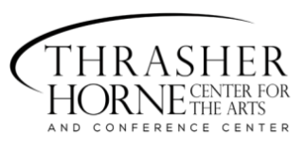
LOYALTY CARD

Present this card to receive 10% OFF!

ANNA ZIRBEL

